Data Explorer 03

An increase in the price of oil of $11 would result in the increase of the US 10 year treasury yield by .279 points.

To obtain this result, I first had to clean the data. This task involved creating a new data frame which used OIS dates as the index (this variable had the highest count). Because quite a few dates did not have a value for one or another variable, I dropped all the NAs, which resulted in the loss of about 100 rows of data. Upon reflection and further study, I would have “forward-filled” the data to eliminate NAs, but since the total loss of data did not seem very large, I persevered with my original course of action.

The scatterplot of all oil prices vs. 10Y yields did not give me the impression of much organization, so I grouped these values by year and made a series of plots. These graphs revealed that for the first couple of years in the data set (2003, 2004, 2005) and 2010 the two metrics are not correlated. However, for the other years there seems to be a relationship of varying strength.

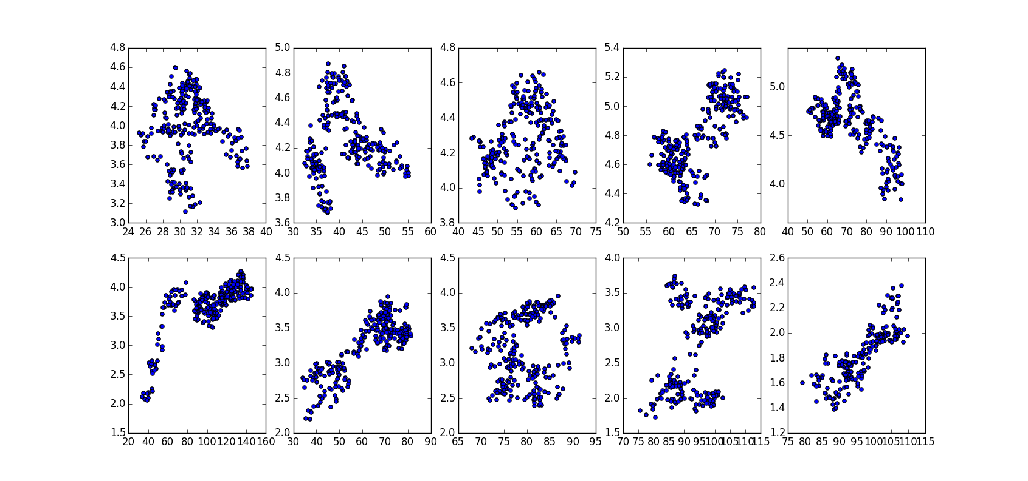

I took the year (2012) which had the strongest correlation in the oil price range and modeled a linear regression on it. 2011, while highly correlated, is bimodal, and 2008 was just a bad year in general.

Multiplying the coefficient of the linear regression line (.0253) by 11 produced the change in 10Y treasury yield.